ECA5701-NANOELECTRONICS
Saambavi U
192512099
CO1
EXPERIMENT 4
Kronig Penney Model

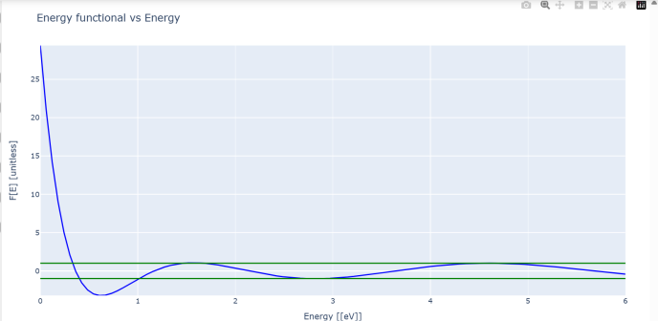
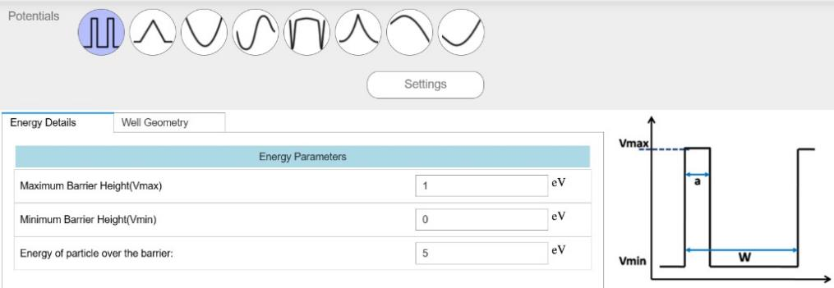

Case Study 1: Simulate the output for Triangular well
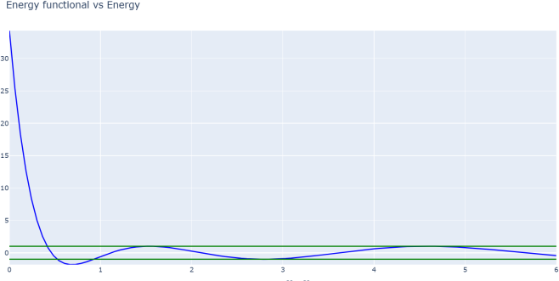

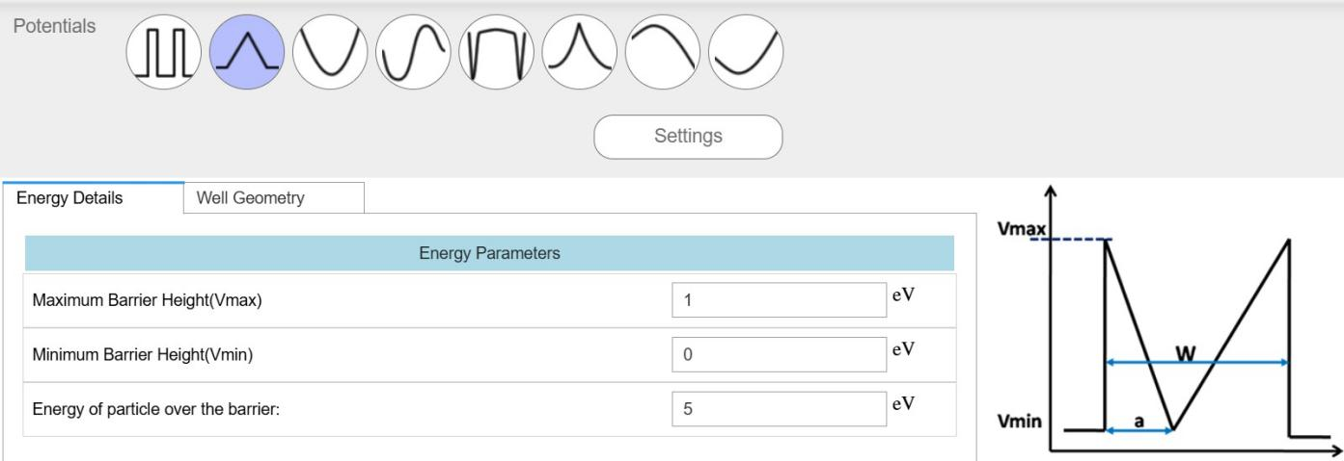

Case Study 2: Simulate the output for Sinusoidal Potential
